30 DAYS CHALLENGE
TASK 1 DONE
SUMAIRA AZIZ
Q1# What does AI-Driven Development mean to you?
AI-Driven Development –
- AI-Driven Development me AI humara partner hota hai, sirf tool nahi.
- Hum AI ko clear instructions/specifications dete hain, aur AI code likhta aur features implement karta hai.
- Hum coder se manager/orchestrator ban jate hain, AI kaam karta hai aur hum direction dete hain.
  - AI Orchestra Example (Beginner Level)
-Socho tum ek restaurant ke manager ho, aur tumhare paas 5 robots hain:
  - Robot 1: Orders le
  - Robot 2: Cooking kare
  - Robot 3: Drinks serve kare
  - Robot 4: Table clean kare
  - Robot 5: Bills prepare kare
Agar tum har robot ko bas vague instruction do:
“Kaam karo”
→ Robots confuse ho jayenge, kaam slow hoga, mistakes honge.

  - Ab Specification-Driven Approach lete hain:
Tum clear instructions doge har robot ko:
  - Robot 1: “Sirf order type A aur B le, aur order ko Robot 2 ko bhej do.”
  - Robot 2: “Order A 10 min me ready karo, Order B 5 min me. Finished order Robot 3 ko bhejo.”
  - Robot 3: “Order ke drinks table 1–5 me serve karo.”
  - Robot 4: “Table clean karo jaise drink serve ho gaya.”
  - Robot 5: “Bill ready karo jaise order complete ho.”
→ Ab sab robots ek saath kaam kar sakte hain, sab coordinated hai, mistakes kam hain.
  - Yeh hi hai AI orchestration:
  - Tum khud sab code nahi likhte.
  - Tum AI ko clear rules aur steps doge → AI khud kaam karega.
  - Tum sirf manager/conductor ho, AI hi workers hai.

- Future me humans creativity aur planning pe kaam karenge, AI execution aur scaling karega.
- Humans + AI saath kaam karke fast, reliable aur complex software bana sakte hain.

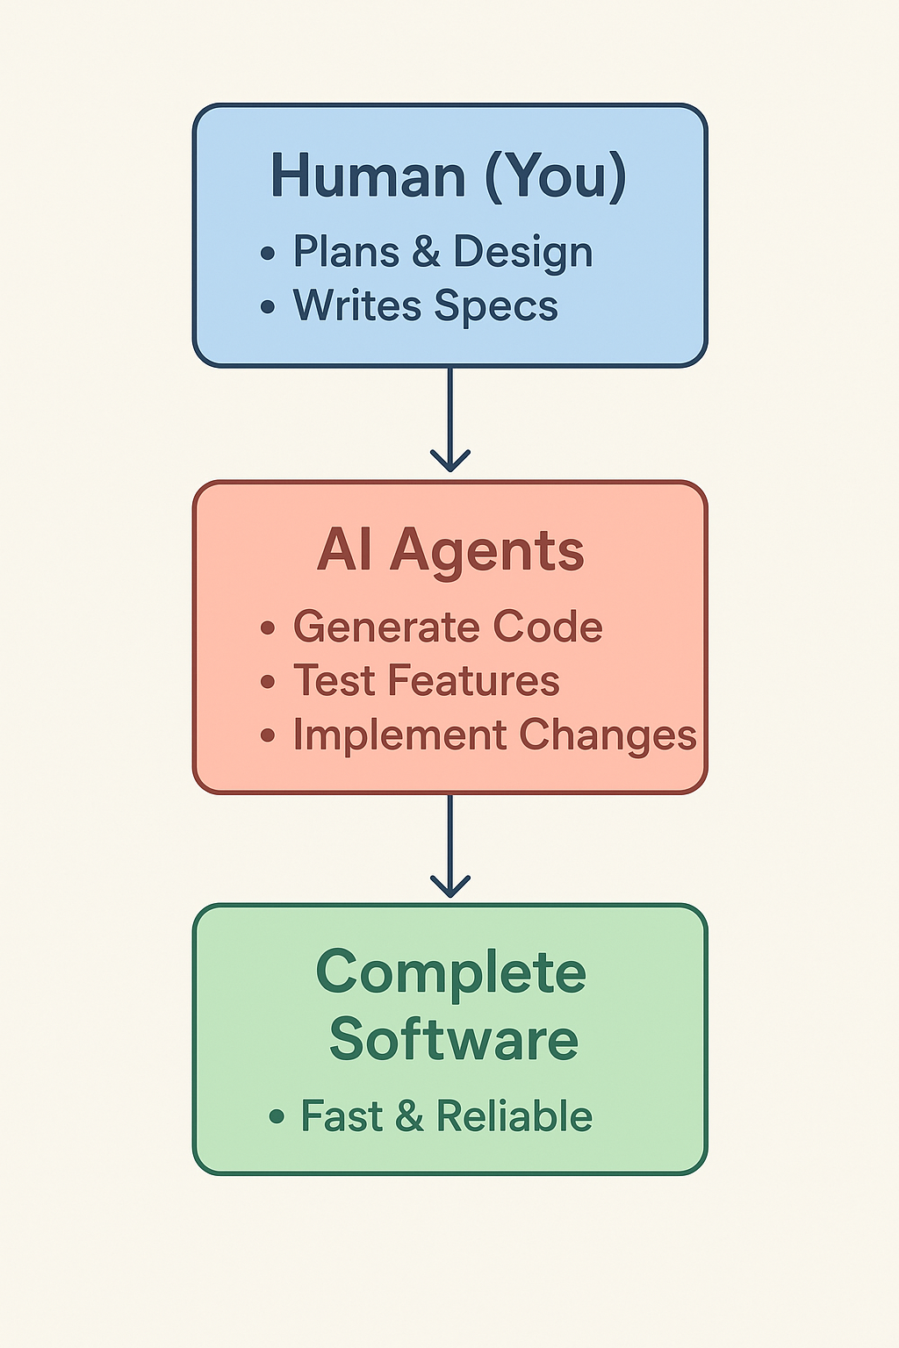

Explanation:
- Tum AI ko instructions doge (jaise manager), AI kaam karega.
- Multiple AI agents ek saath kaam kar sakte hain, mistakes kam hoti hain aur development fast hota hai.
- Tum sirf planning aur decision-making pe focus karte ho.

Summary:
“Humans aur AI saath kaam kar ke aise systems build kareinge jo pehle impossible lagte the.”

Q#2 : How do you see the future of Human–AI Collaboration in software development?
⭐ Future of Human–AI Collaboration
- AI will help write code faster
Developers will explain what they want, and AI will generate the code instantly.
- Humans will focus on ideas, design, and creativity
Instead of typing every line, developers will guide the AI.
- AI will catch mistakes automatically
Bugs, errors, and security issues will be detected and fixed quicker by AI tools.
- Development will become easier for beginners
Even new learners will be able to build apps using simple instructions to the AI.
- Humans + AI = smarter solutions
AI handles repetitive tasks, humans handle logic and decision-making.
- Projects will be completed faster and with better quality
Less time on manual work, more time on building features and improving user experience.
- AI will act like a smart teammate
Not replacing developers—just helping them work better and faster.

🧠 Self-Test (MCQs)
1️⃣ What is the main purpose of the AI-Native Era?
a) Replace developers
b) Empower developers through AI tools
c) Eliminate coding
d) Automate testing
2️⃣ What defines an AI-driven developer?
a) Writes only syntax
b) Creates context-aware prompts
c) Avoids tools
d) Works offline
3️⃣ What does “AIDD” stand for?
a) AI-Integrated Data Design
b) AI-Driven Development
c) Automated IDE Deployment
d) Adaptive Input Debugger
4️⃣ What is the focus of Evaluation-Driven Development (EvDD)?
a) Manual coding
b) Evaluating and improving AI outputs
c) UI design
d) Testing only
5️⃣ What should developers focus on in the AI era?
a) Syntax only
b) Building reasoning + evaluation skills
c) Avoiding AI tools
d) Manual workflows

